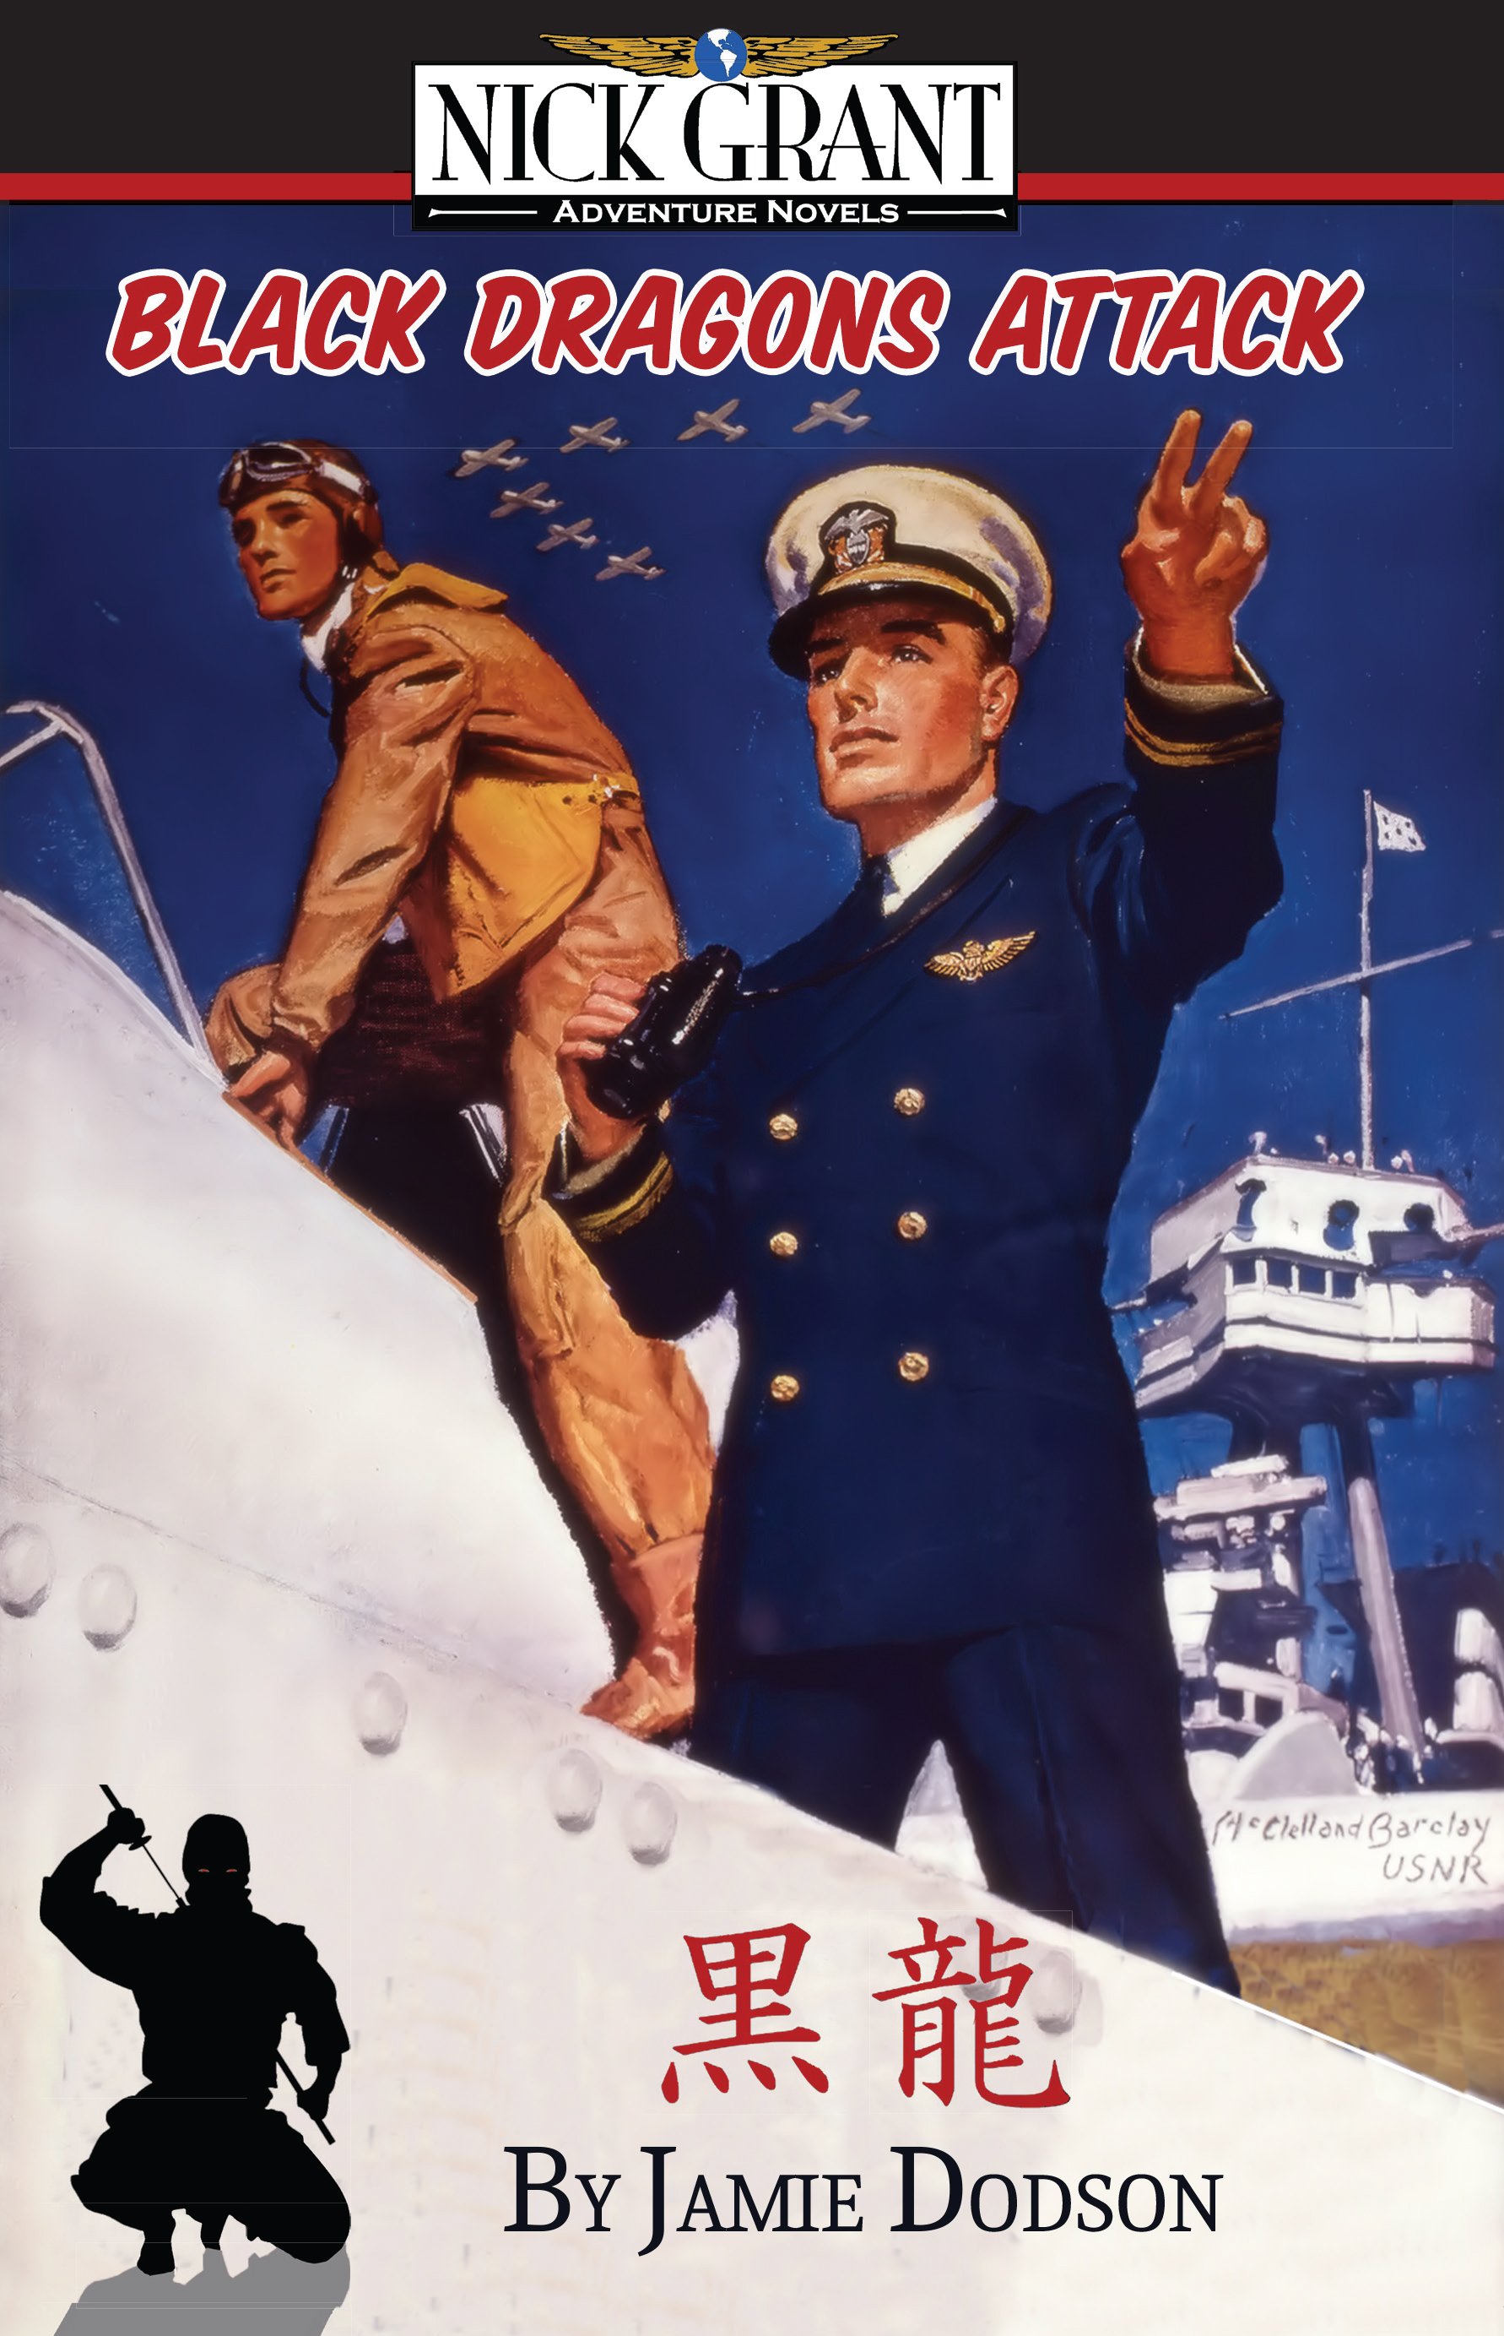

FOR IMMEDIATE RELEASE For more information:
Wendy Reeves
wendyr@wynsum.net
256.384.5232

Huntsville author Jamie Dodson releases fourth book in October
Huntsville, Ala. — North Alabama author Jamie Dodson’s fourth book is out this month from his award-winning Nick Grant Adventures series. The historical fiction novels are set during the Golden Age of Aviation, and are appropriate for young teens and older.
The newest book, Black Dragons Attack, finds Dodson’s main character, Nick Grant, interacting with Howard Hughes and racing to protect classified aircraft plans from Japanese spies. It’s a fast-paced continuation of Dodson’s series, including Flying Boats & Spies, China Clipper and Mission Shanghai.
"My novels are historical fiction,” Dodson says. “Virtually all the people are real; the events are real but told through a fictional character."
Dodson has a lifelong love of boats and planes. It was through his adventures during a career in military intelligence that the idea for the books came about. When his career slowed down to 40-hours a week in the early 2000s, he finally started writing.
At the beginning of World War II, Dodson says, the flying boats were the only planes capable of crossing oceans with a usable load. The flying boats were built for Pan American Airways, and its new route was considered the Orient Express of the Pacific.

His books weave the story around the building of Pacific Island flying boat bases, a world on the brink of war, and enemy spies — all told through a fictional character named after a former boss and mentor, Major General Nicholas P. Grant.
Dodson’s first book, Flying Boats and Spies, released in 2008, won the Eric Hoffer Fiction Award and was optioned by a California production company for a major motion picture. All are available for purchase at jamiedodsonbooks.com and amazon.com.

